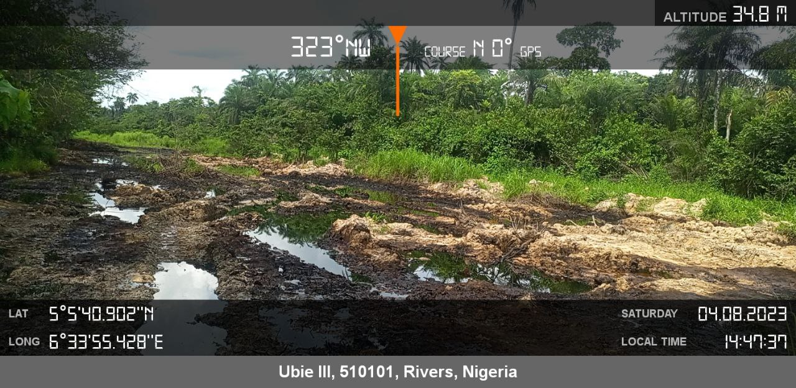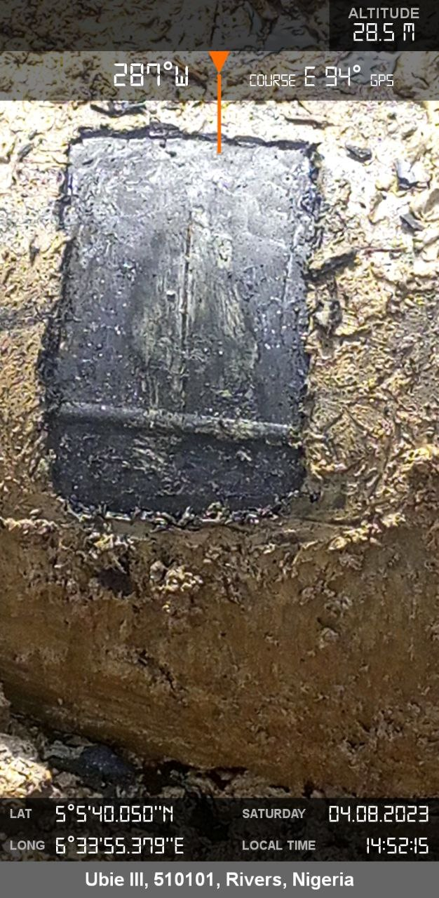
Figure 1 Arrow showing disturbed/impacted Area Figure 1 Arrow showing spill point

